**PRACTICE 1**

1.The HR department wants a query to display the ename, job, hiredate, and empno for each employee, with empno appearing first. Provide an alias “STARTDATE” for the HIREDATE column.

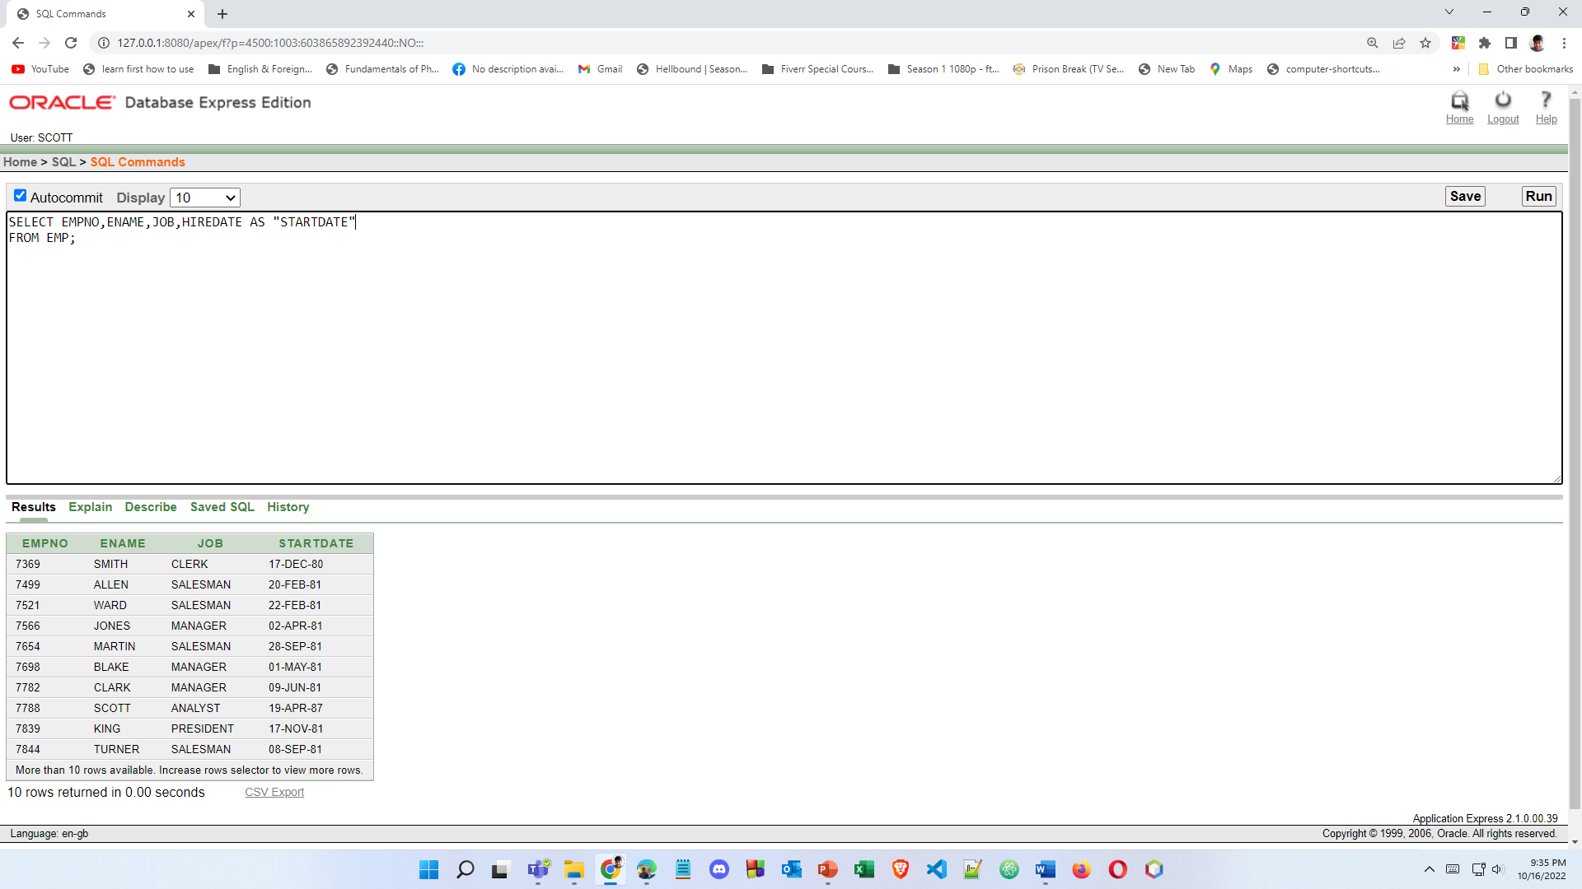

2.The HR department needs a query to display all unique job from the EMPLOYEES table.

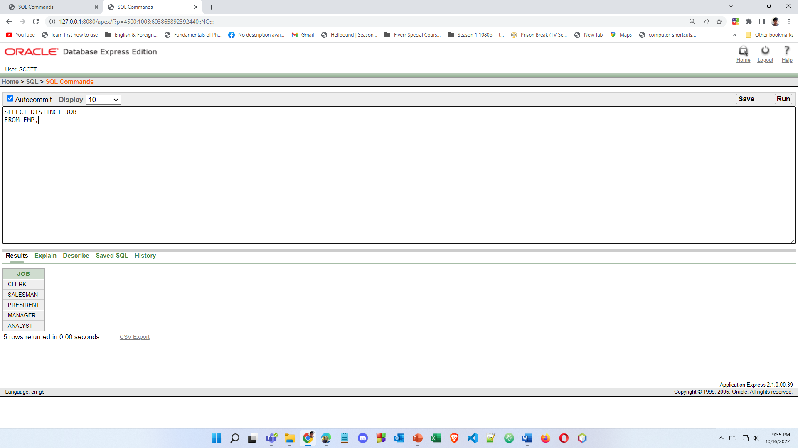

3.The HR department wants more descriptive column headings for its report on employees. Name the column headings Emp # for empno, Employee for ename, Job for JOB, and Hire Date for HIREDATE, respectively. Then run your query again.

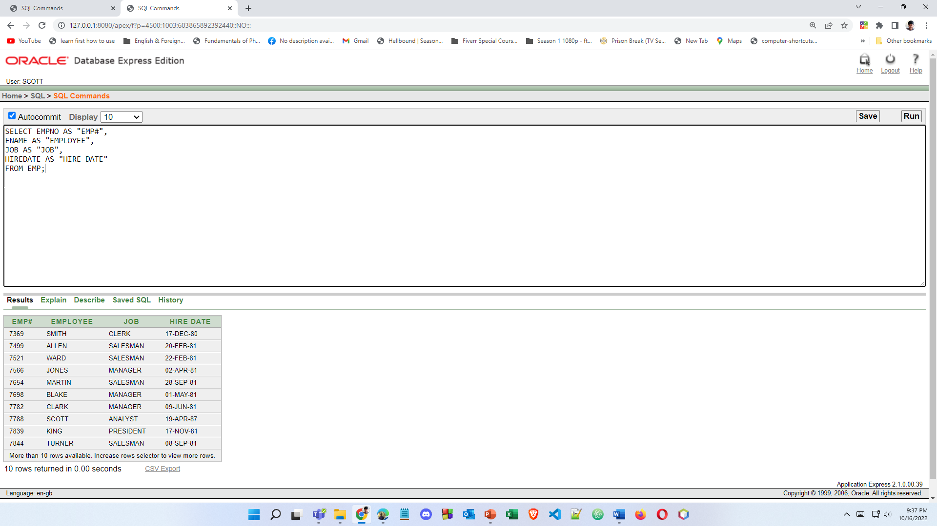

4.The HR department has requested a report of all employees and their salary. Display the ename concatenated with the salary (separated by a comma and space) and name the column Employee and Title.

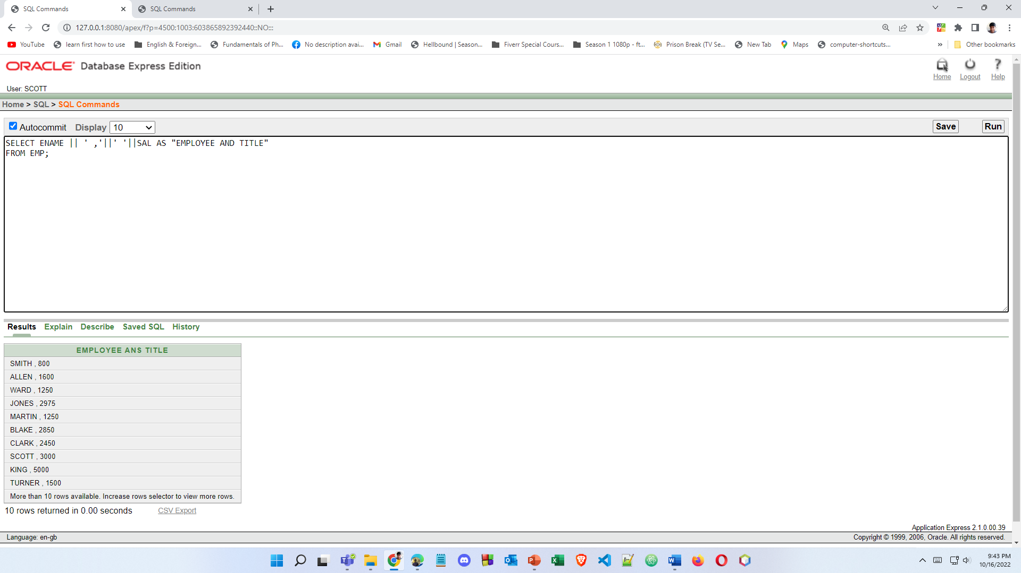

5.To familiarize yourself with the data in the EMP table, create a query to display all the data from that table. Separate each column output by a comma. Name the column title THE_OUTPUT.

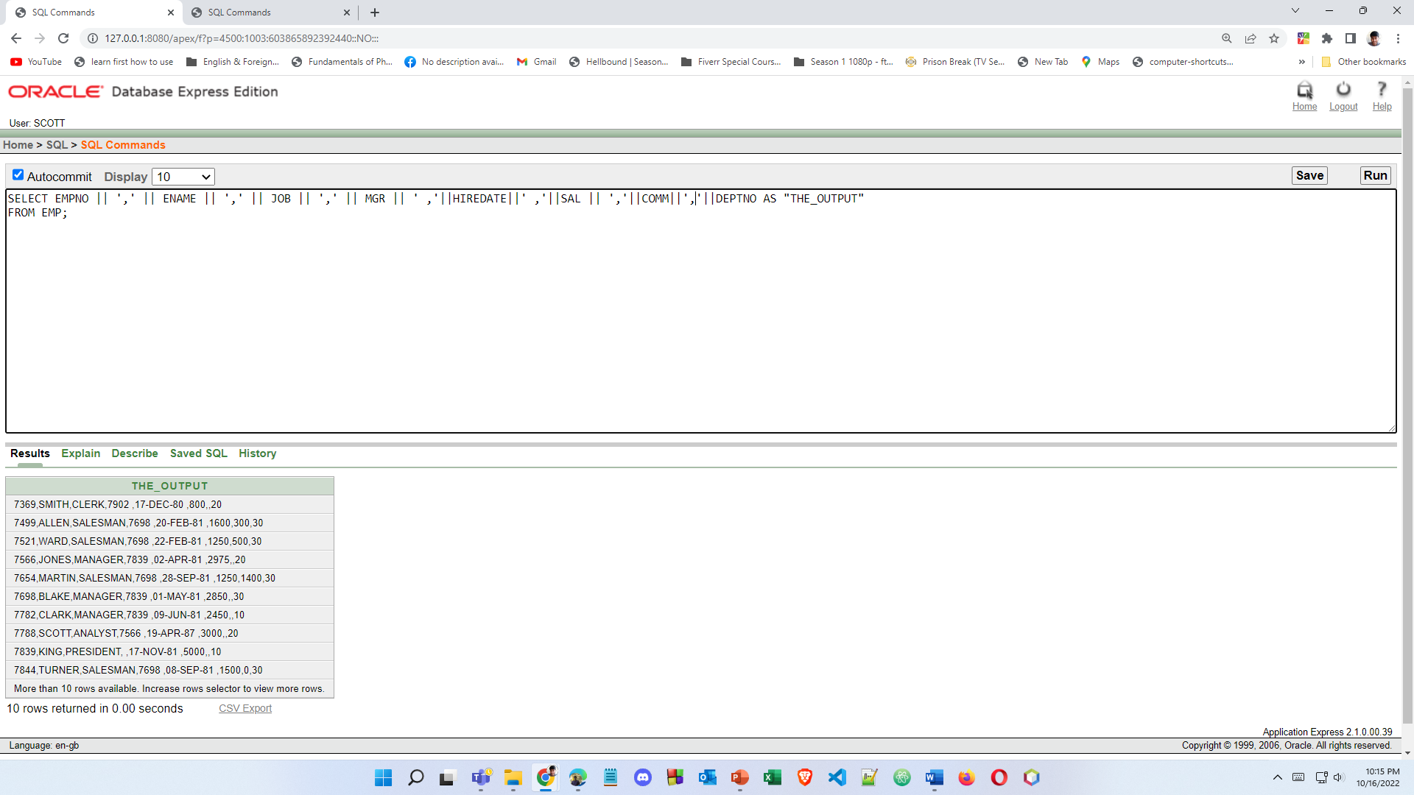

6. List the deptno from emp uniquely

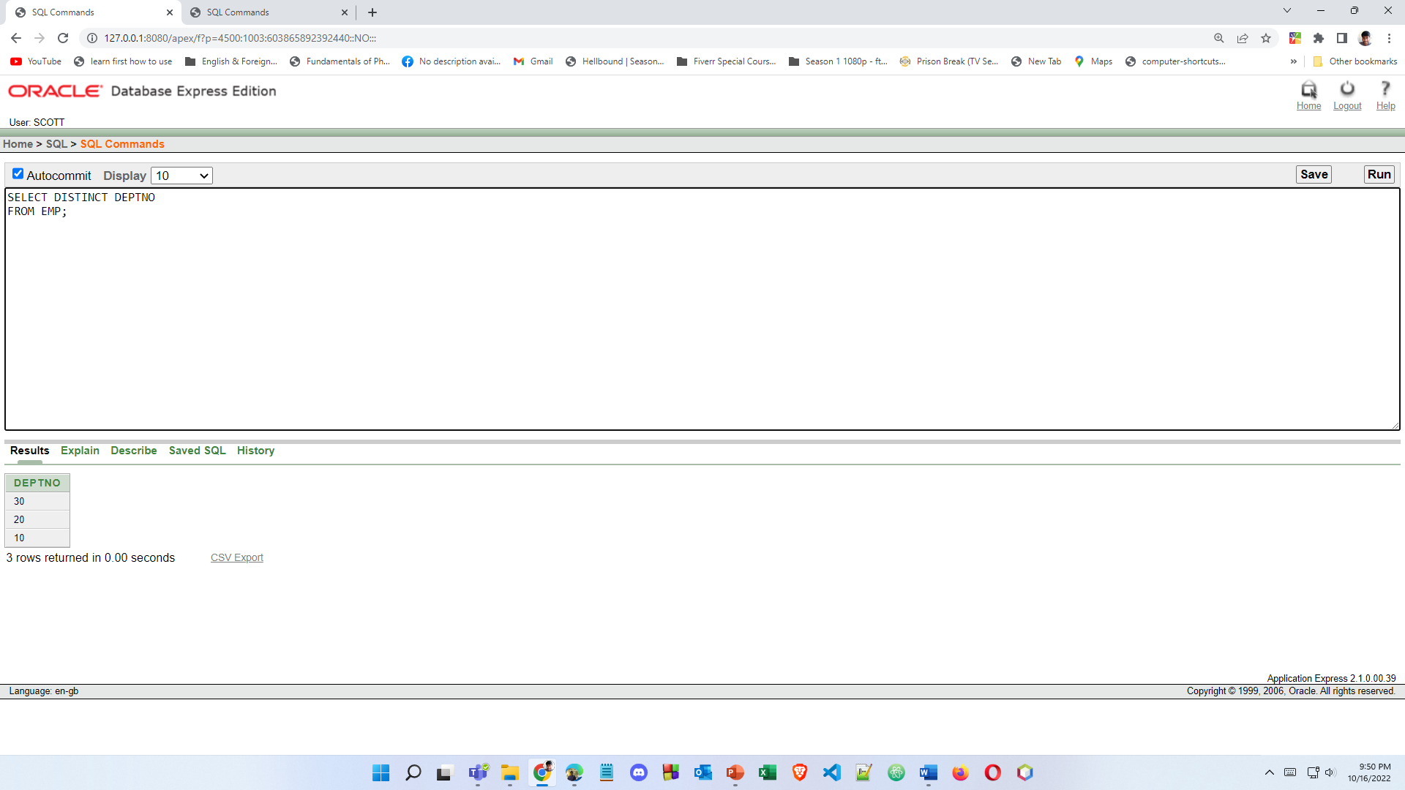

7. Show the information of all employees like “SMITH go salary $ 800”

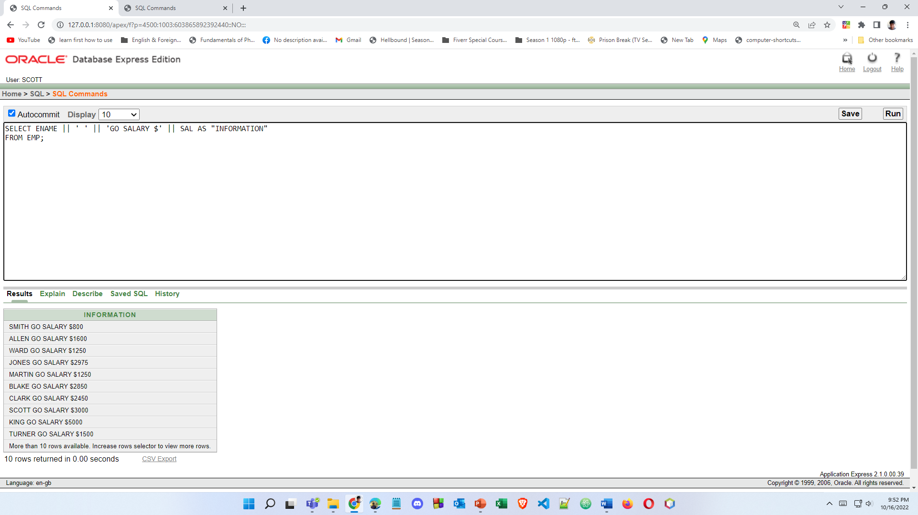

8. Check whether all the empno are indeed unique

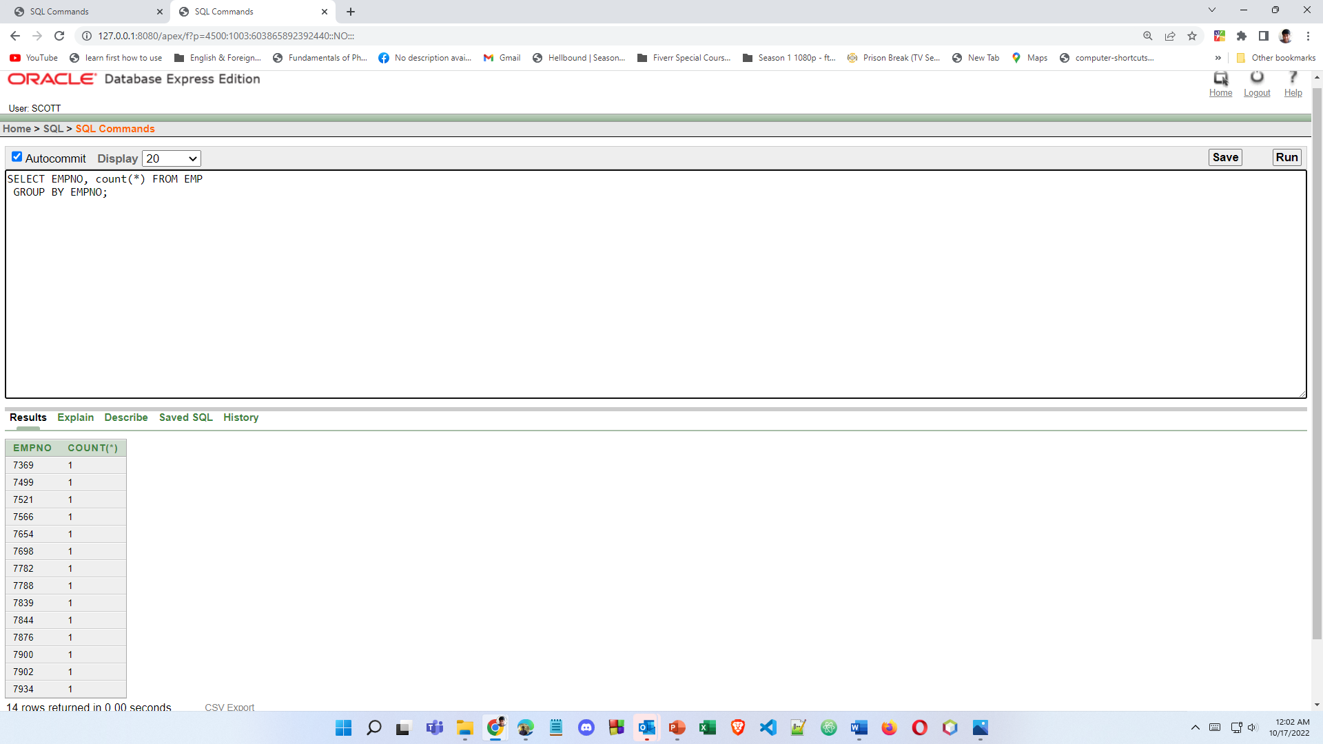

9. List “Annual salary” for all employee use column aliasing

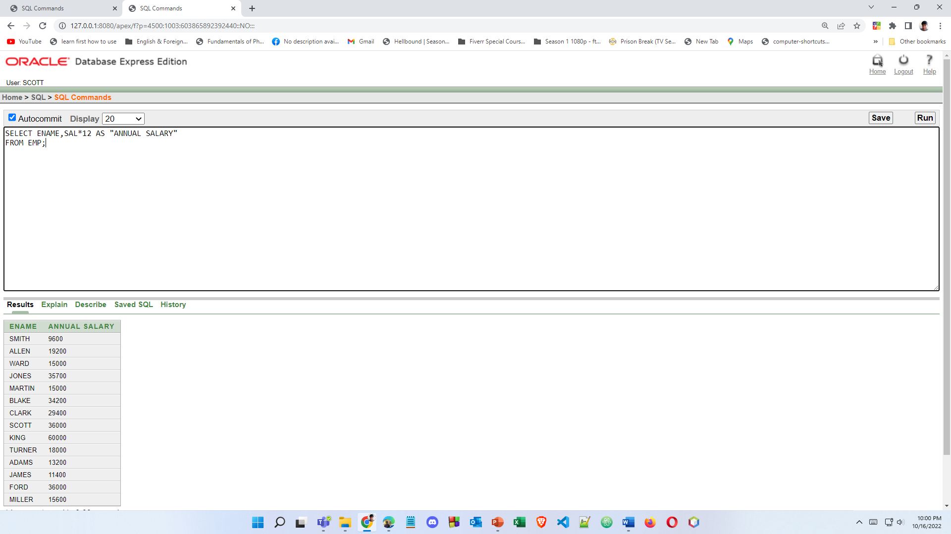

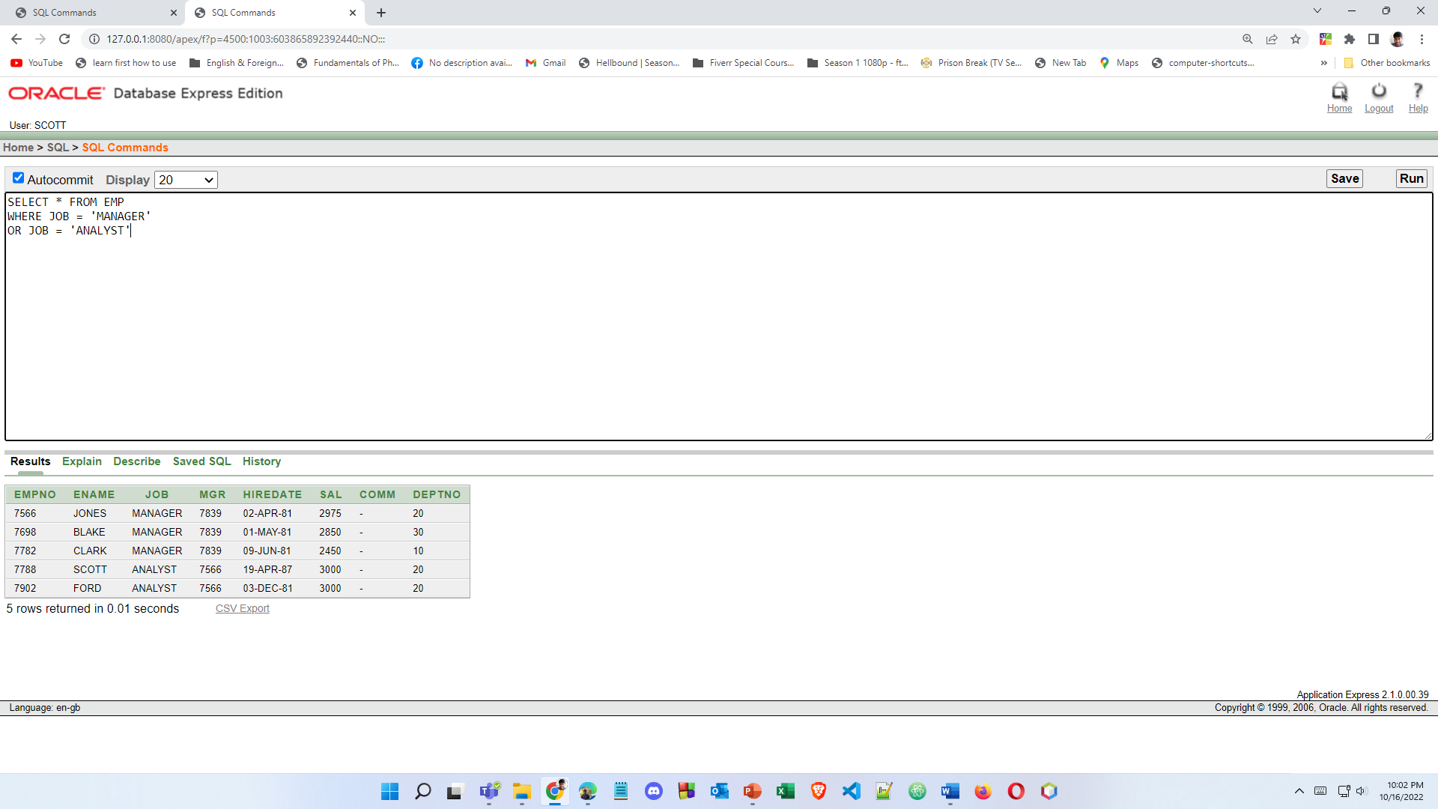10. List the information for all employee whose job is either MANAGER or ANALYST

1. List the department name whose department no is 20

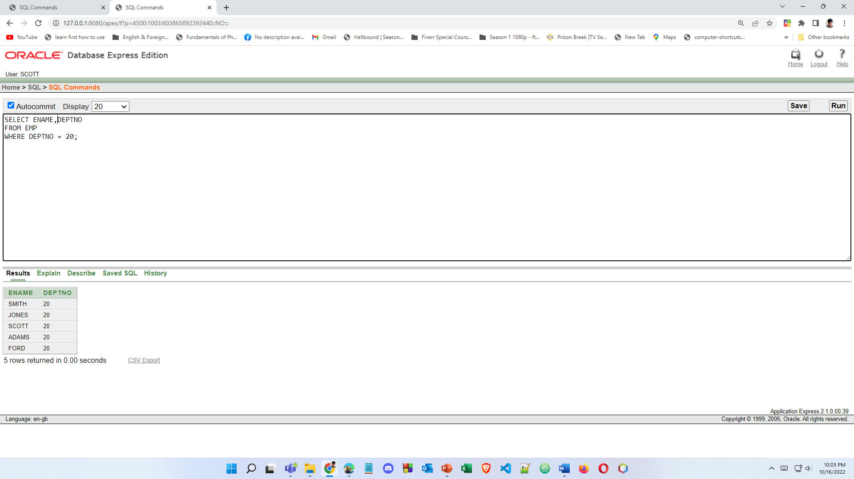

**PRACTICE 2**

1. Create a query to display the name,salary,commision of employees earning more than $2850

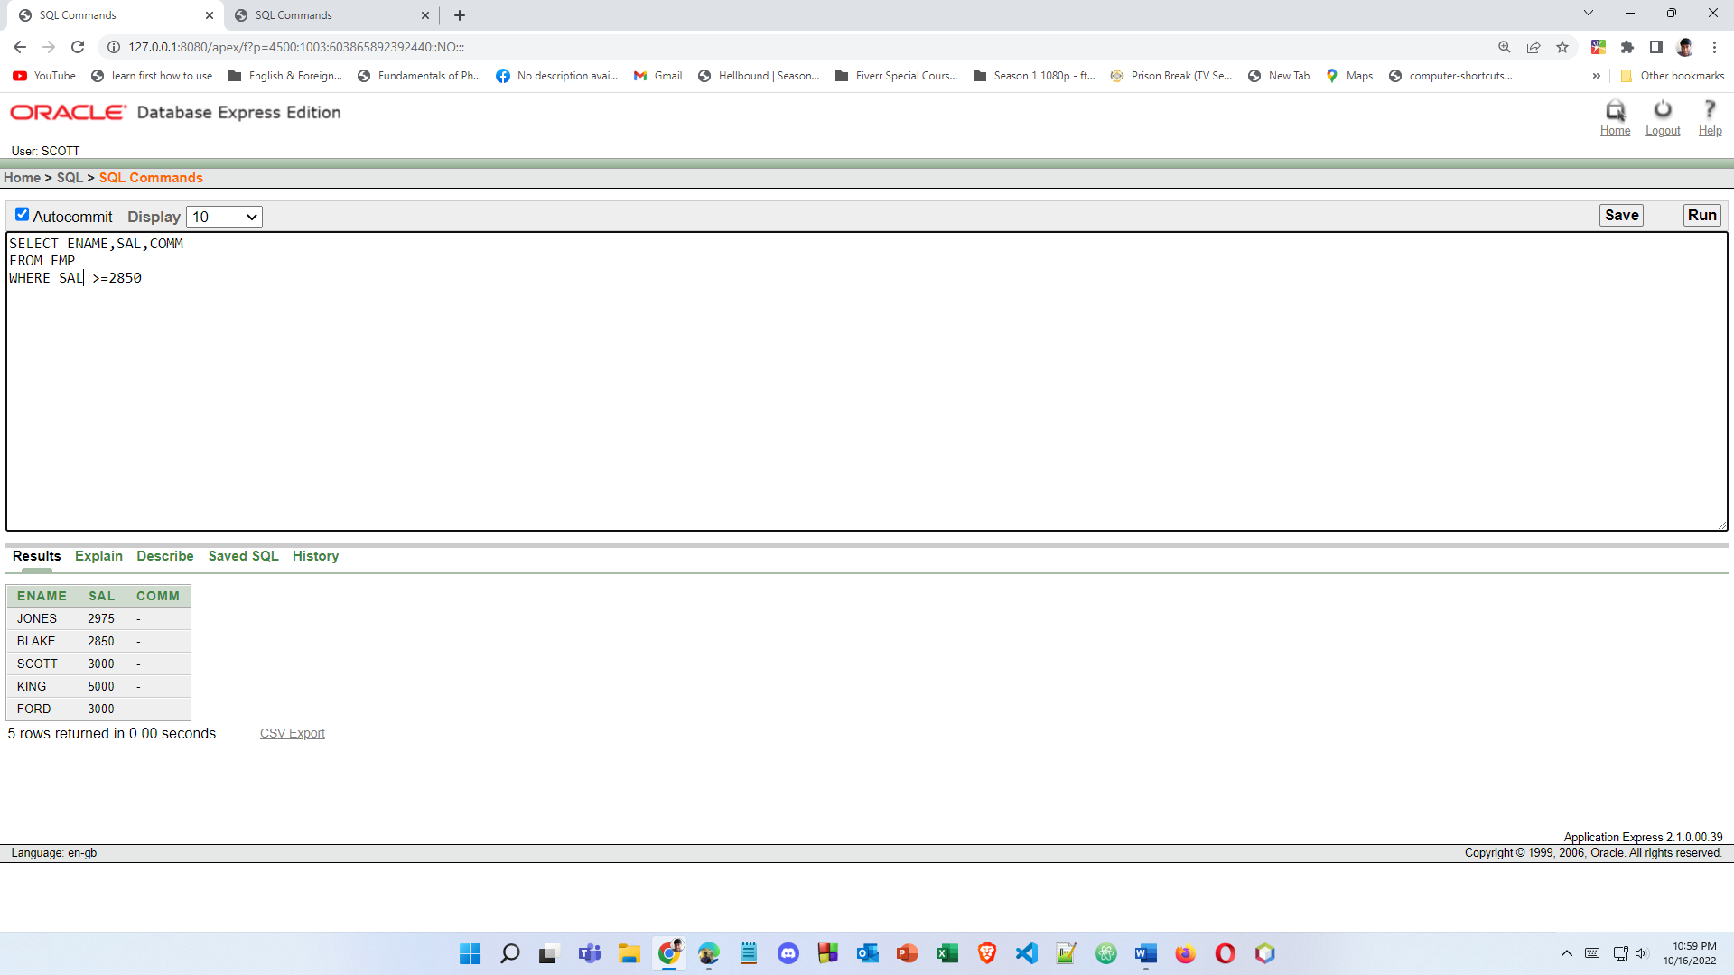

2.Create a query to display the employee name, salary and department number for employee number 7566.

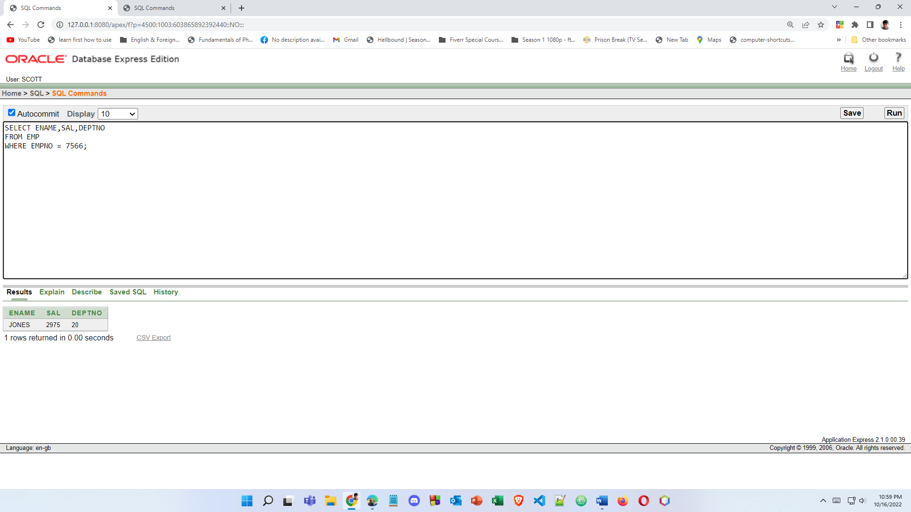

3.Display the name and salary for all employees whose salary is not in the range of $1500 and $2850

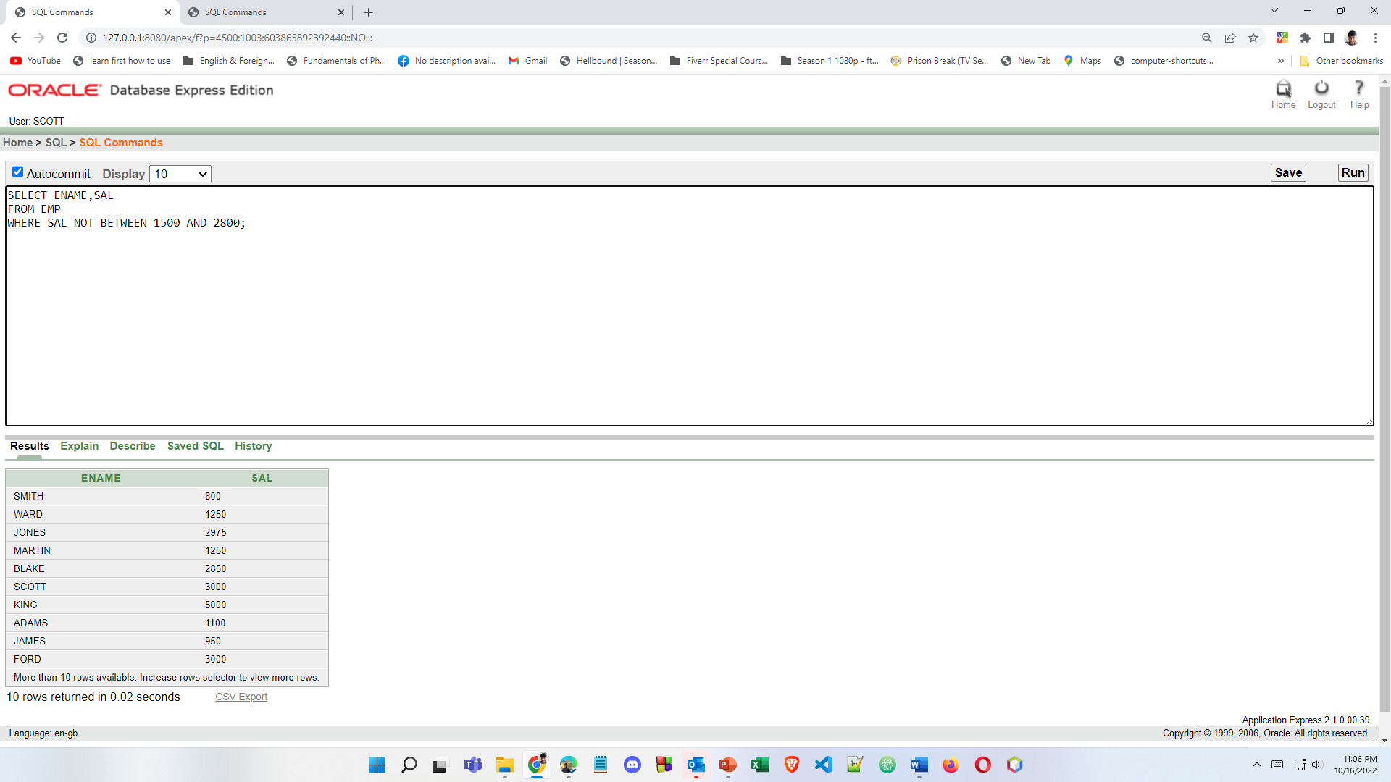

4.Display the employee name, job, and start date of employees hired between February 20, 1981, and May 1, 1981. Order the query in ascending order by start date.

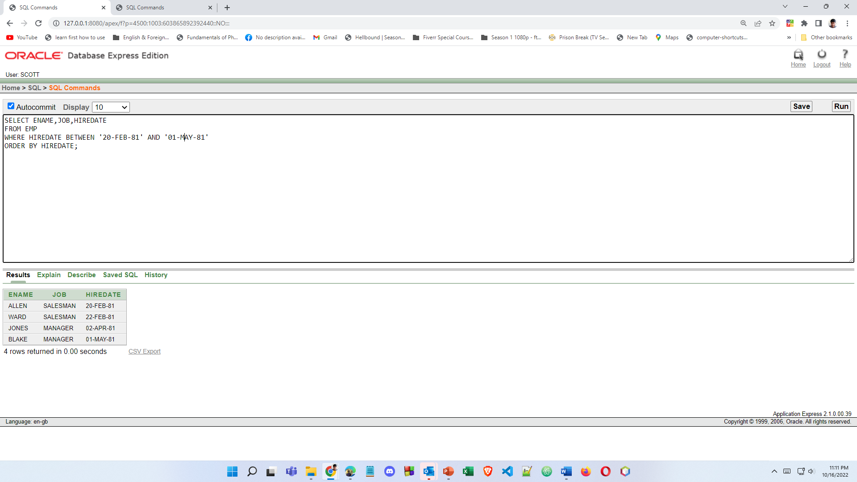

5.Display the employee name and department number of all employees in departments 10 and 30 in alphabetical order by name.

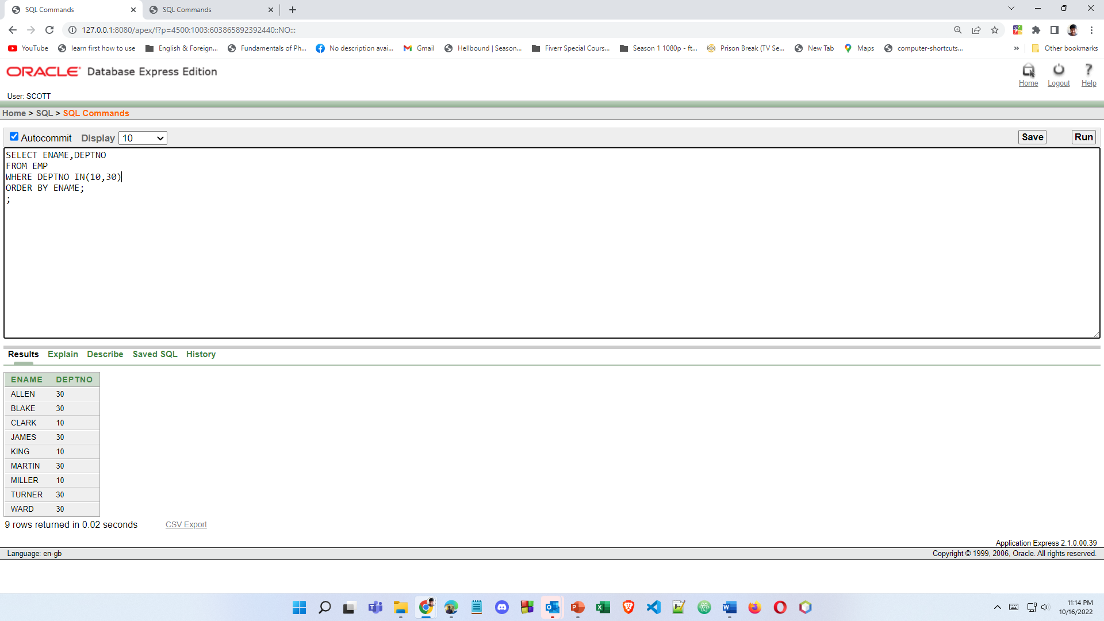

6.Display list the name and salary of employees who earn more than $1500 and in department 10 or 30. Label the columns Employee and Monthly Salary, respectively.

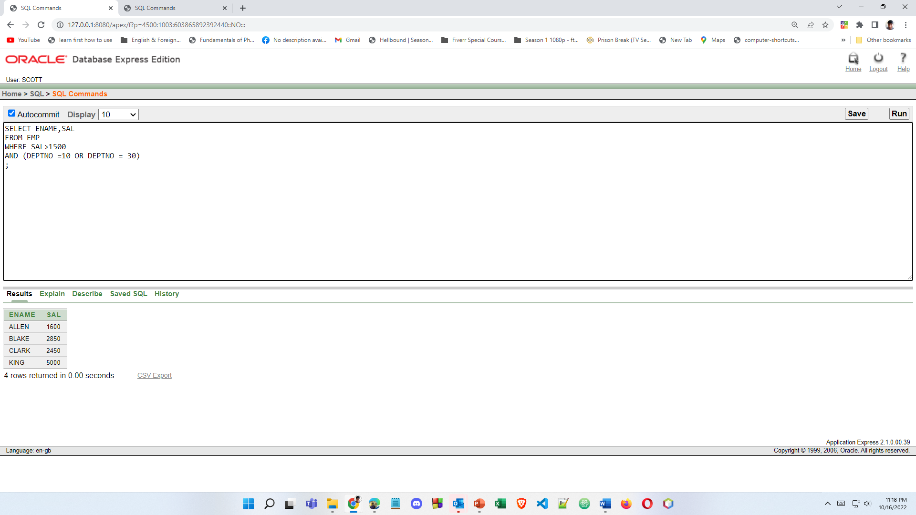

7.Display the name and hire date of every employee who was hired in 1982

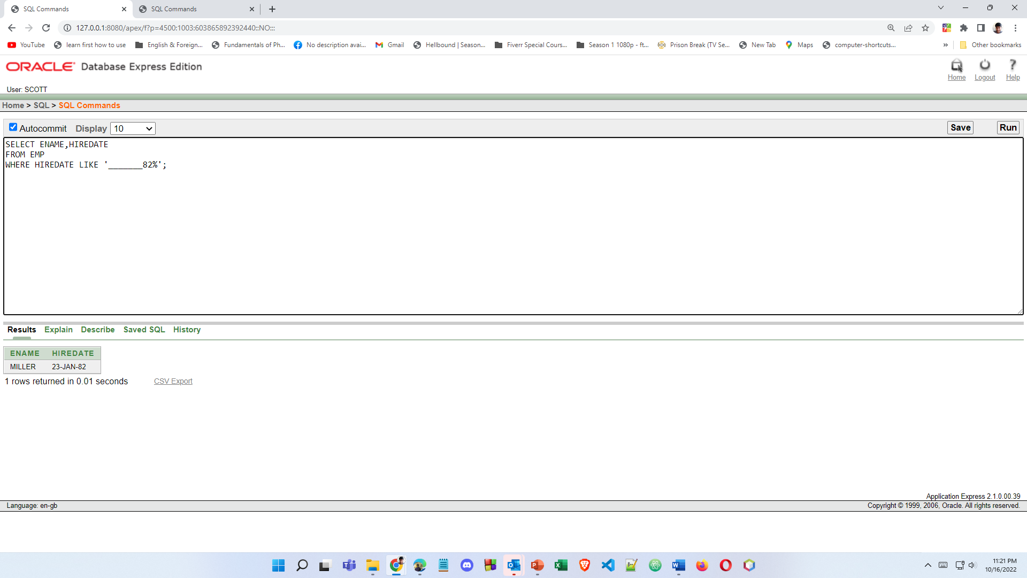

8.Display the name and job title of all employees who do not have a manager.

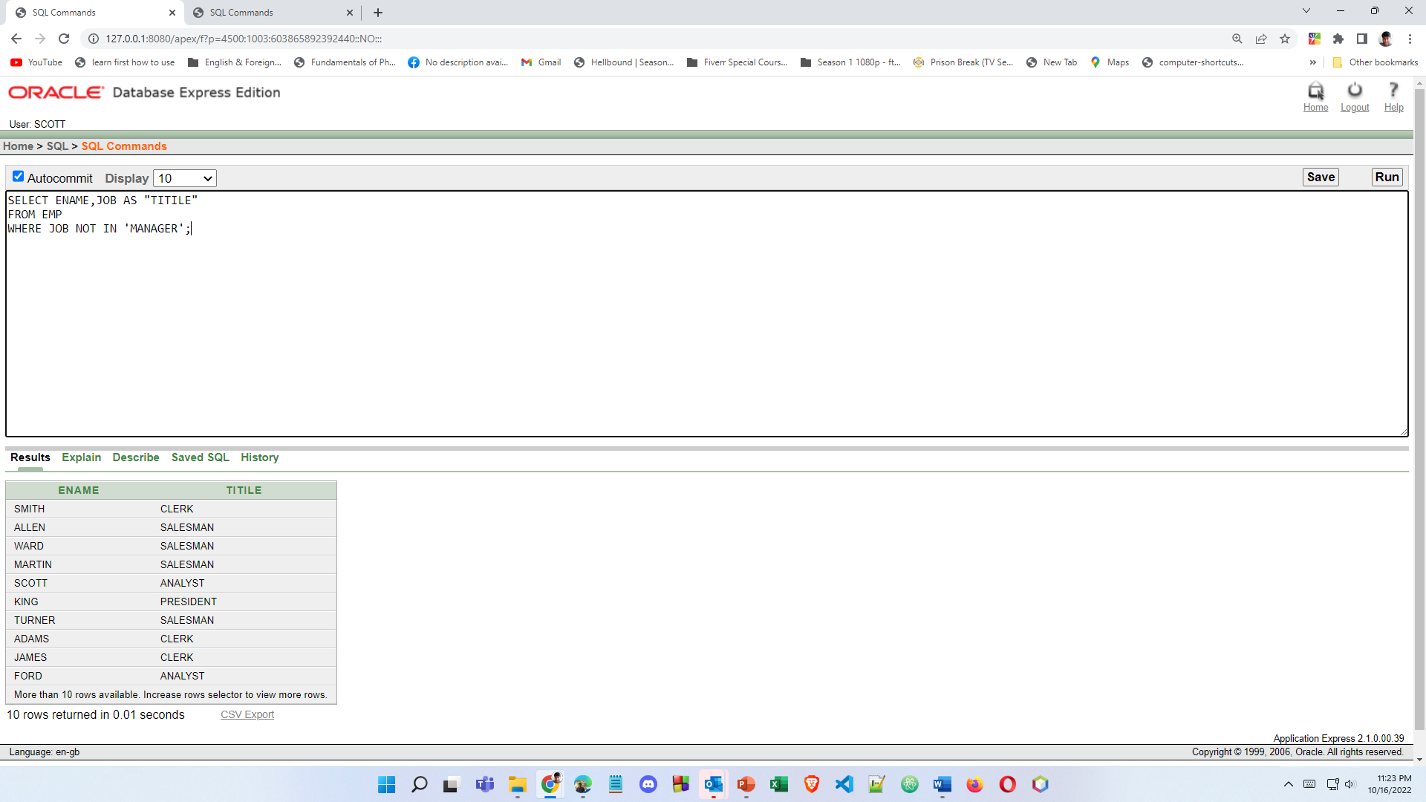

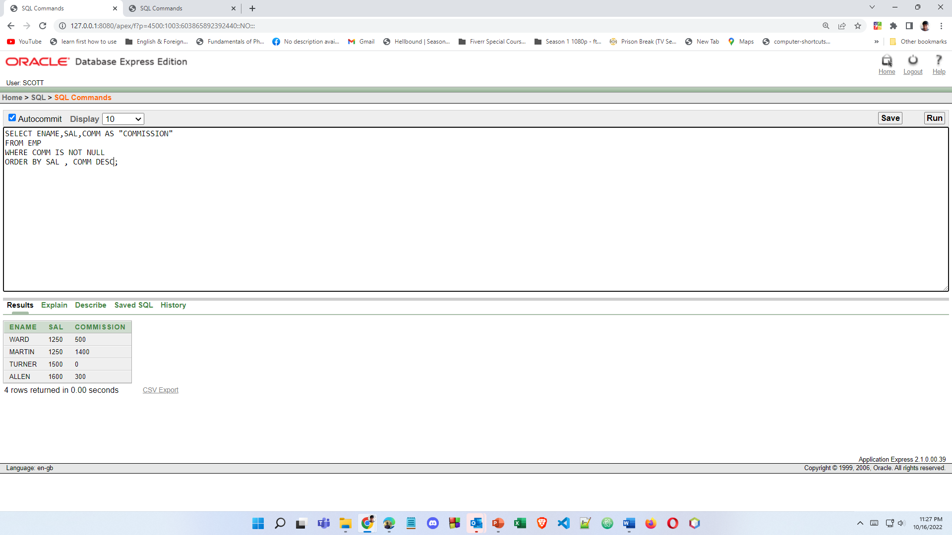9.Display the name, salary, and commission for all employees who earn commissions. Sort data in descending order of salary and commissions.

10.Display the names of all employees where the third letter of their name is an *A*.

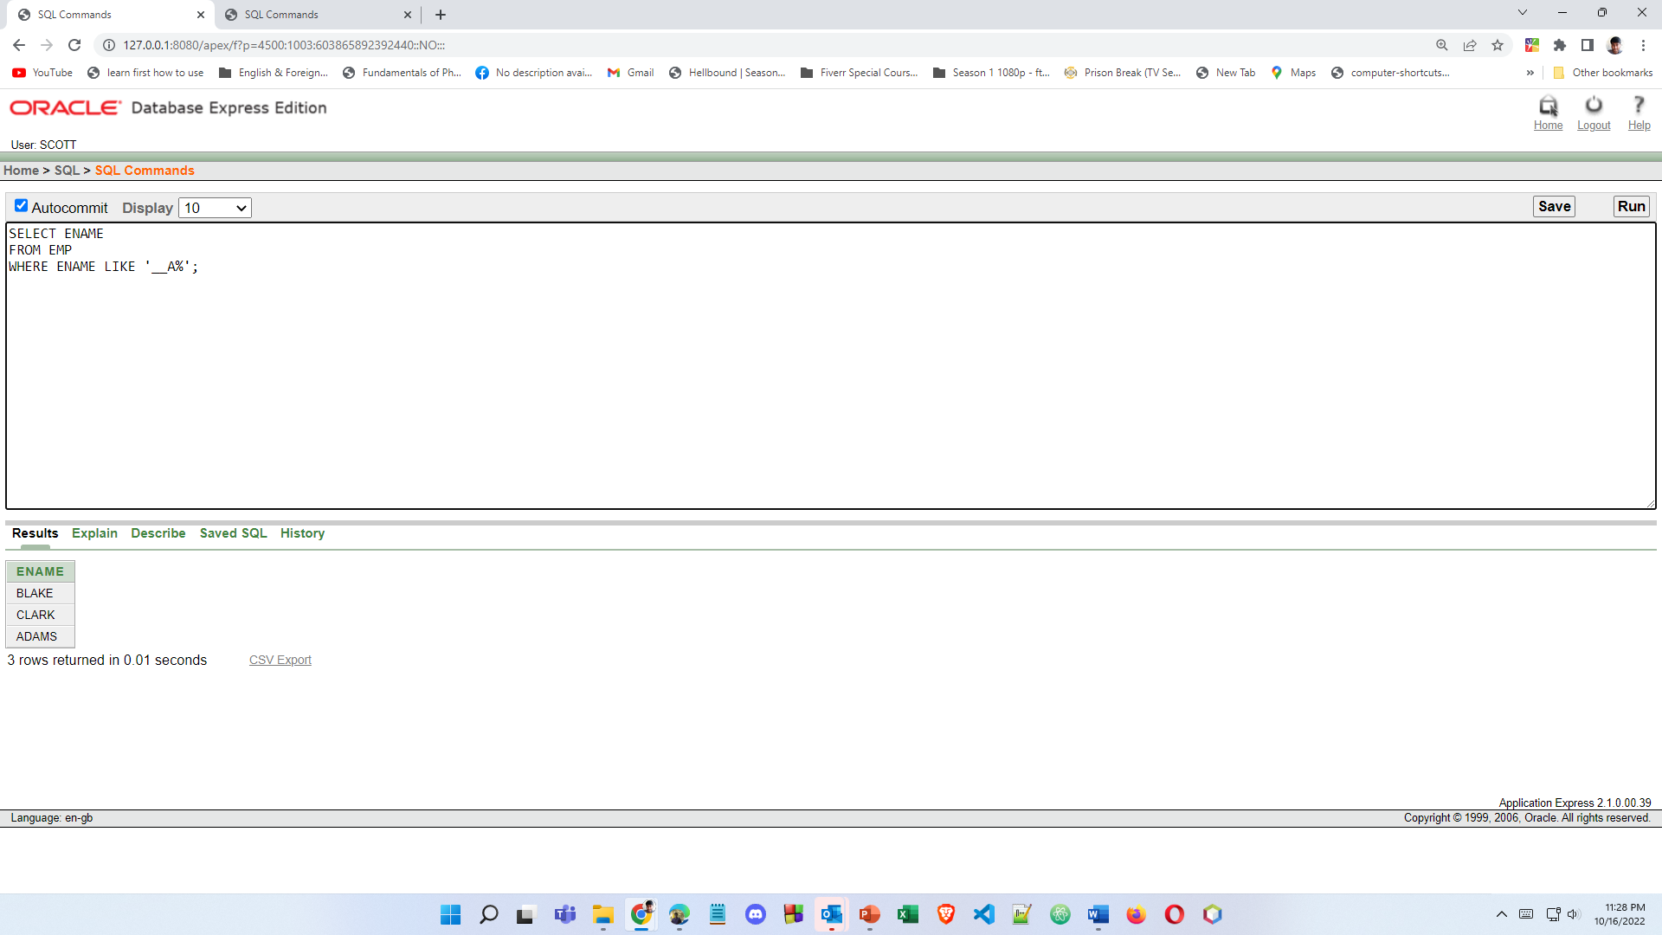

11.Display the name of all employees who have two *L*s in their name and are in department 30 or their manager is 7782.

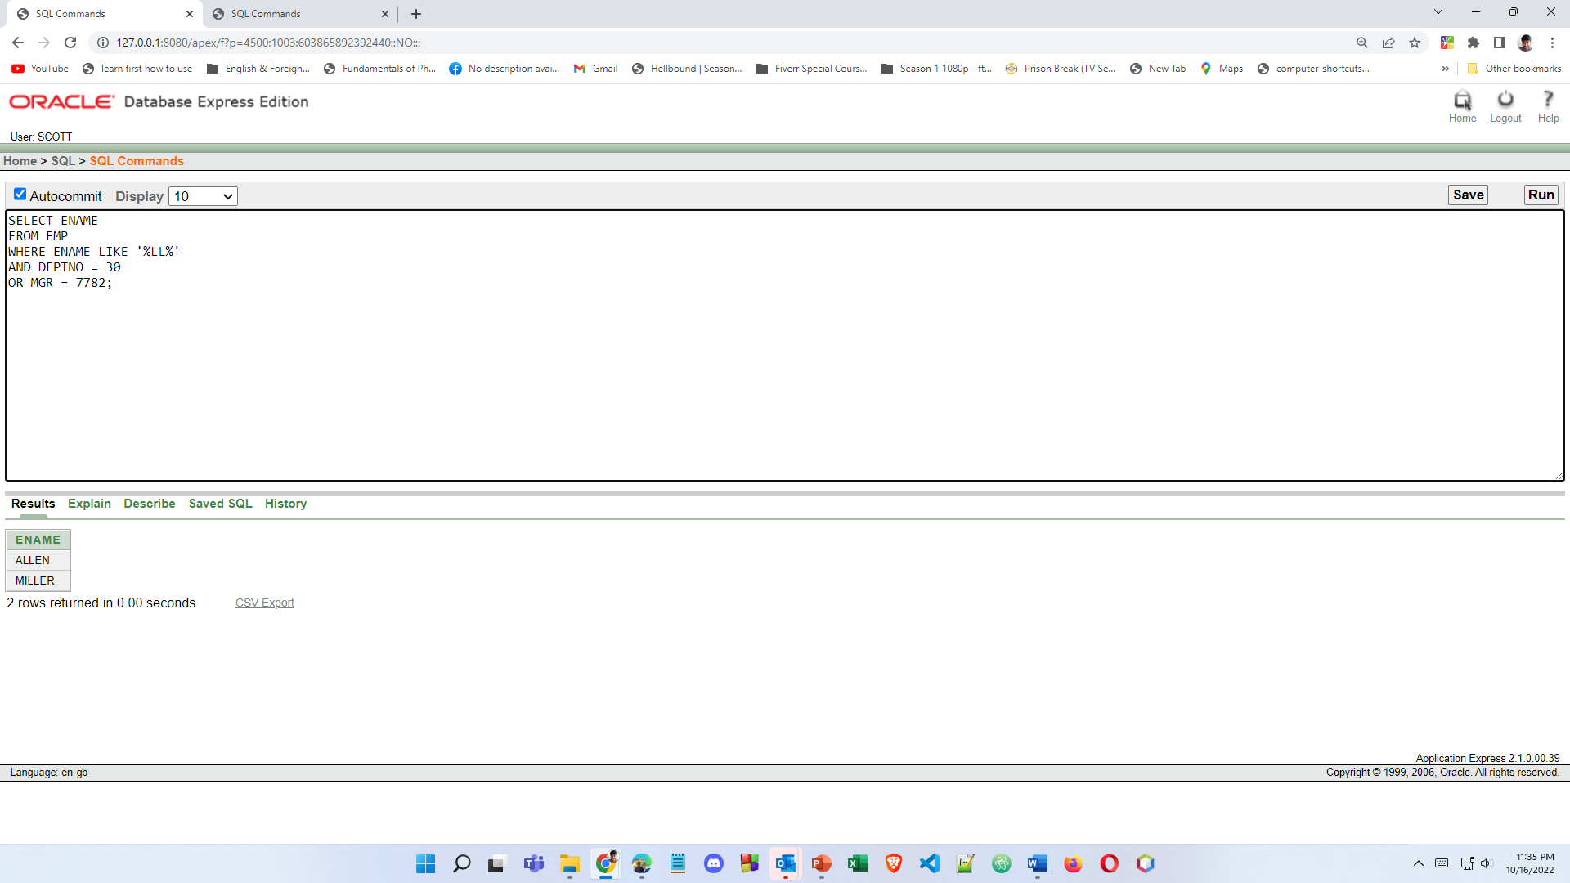

12.Display the name, job, and salary for all employees whose job is Clerk or Analyst and their salary is not equal to $1000, $3000, or $5000.

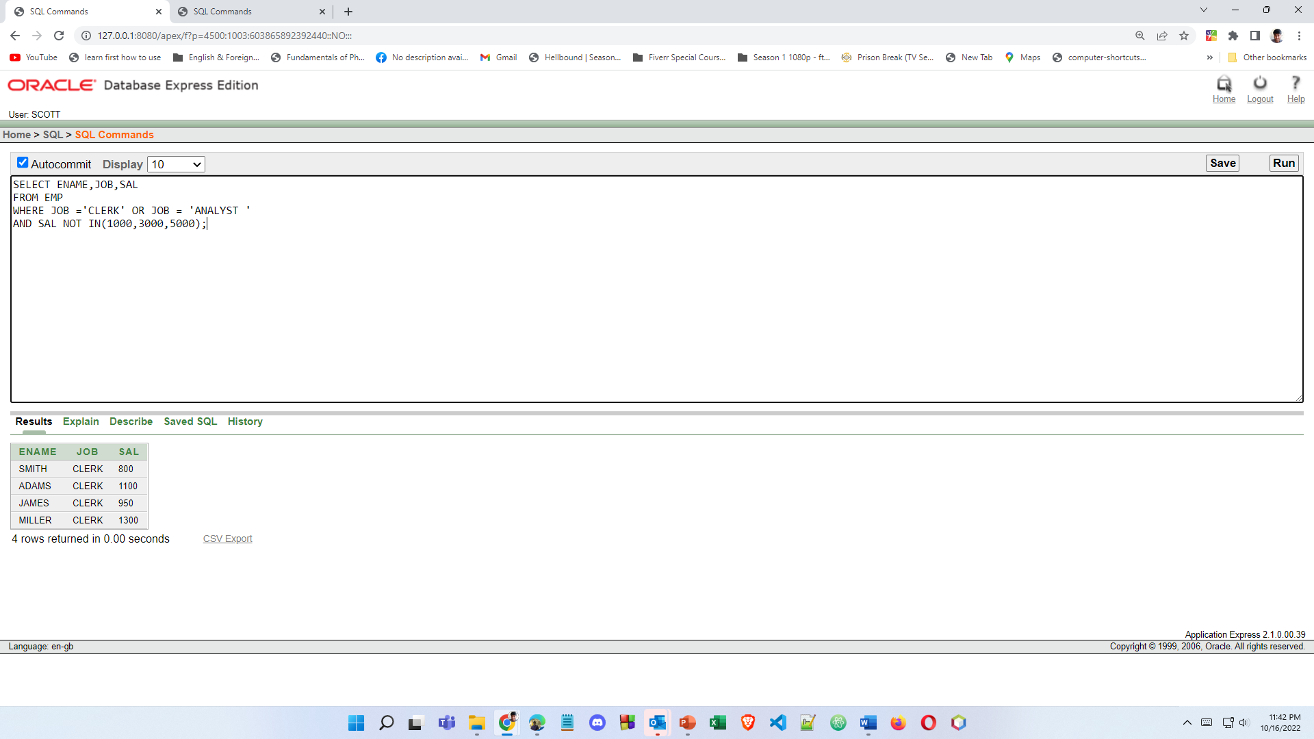

13.Display the name, salary, and commission for all employees whose  
commission amount is greater than their salary increased by 10%.

